Loops and if's | Exercises

**Task 1**

**1. Odd Numbers**

Create a program to display on the screen the odd numbers from 76 to 46 (downwards), using a "while" loop. Use variables to hold the start number (eg. 76) and the end number (eg. 46) so the range can be easily changed without modifying the program code.

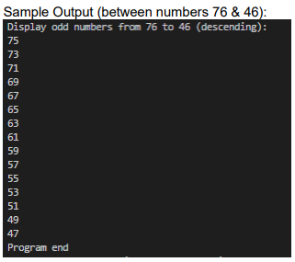

**Task 2**

**2. Repeat Character**

Write a program that asks the user for a character/symbol and a counter value. The program

outputs that character/symbol repeated as many times as the user has indicated, as in the following

**example:**

Input:

Enter a character/symbol: &

Enter counter value: 7

**Output:**

&&&&&&&

Display the output three times: first using a “for” loop then a “while" loop, and finally a “do-while" loop. Remember the “do-while” loop is post-tested, ie. it will run at least once!

**Task 3**

**3. Rectangle**

Write a program that draws a rectangle. The width and a height of the rectangle and the inner symbol used to construct the rectangle can be pre-set using variables.

Example: Character:/symbol: $ Width: 3 Height: 4

